Assessment in Music

Informing Pupils of Targets:
- Following unit title pages in class Music evidence files, pupils have an assessment objectives grid which is shared with them at the beginning of each lesson.
- This ensures that pupils are accurately informed about the skills and knowledge they will be developing within every lesson and over time as part of a wider unit of work
- Pupils self and peer-assess (where appropriate) against the assessment objectives on the jigsaw grid at the end of each lesson

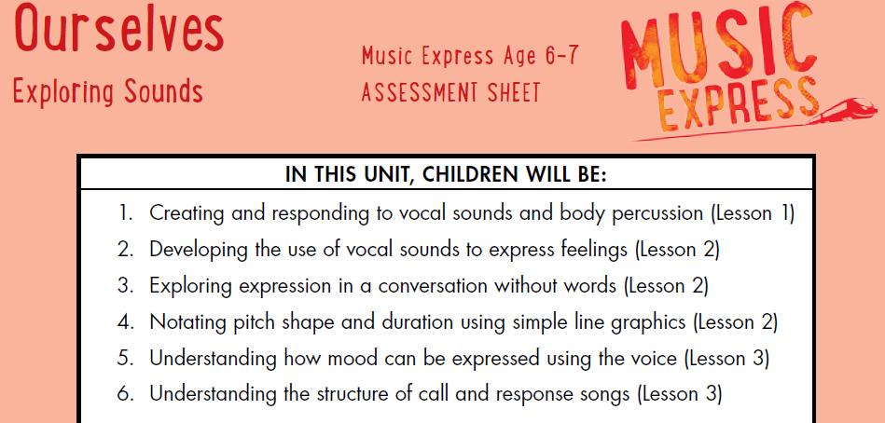

Ongoing Assessment:
- Class Teachers and HLTAs (where appropriate) use a range of Assessment for Learning strategies in order to formatively assess pupils’ achievements and progress within lessons.

Formal Assessment:
- Pupils’ achievements and progress is assessed formally by Class Teachers at the end of each unit of work (once per half term).
- Class Teachers complete an end of unit assessment grid identifying which pupils are Working Towards ARE, Working at ARE and Working at GD (using AfL over the course of the unit of work)
- The completed assessment grid is placed in Music class evidence folders

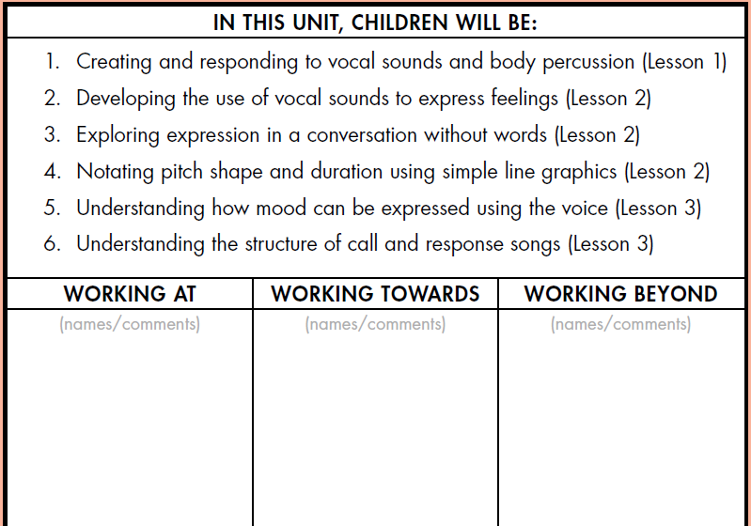

Reporting and Tracking:
- Class Teachers share completed assessment grids with the Subject Leader and Curriculum Lead (DHT) at the end of each unit of work
- The data submitted is analysed by Leaders in order to identify trends and areas for further development

Moderation:
- Non-Core assessment data is reviewed termly by Subject Leads, the Curriculum Lead and SLT and is subject to internal moderation.
- Class teachers discuss the attainment and progress of pupils in all non-core subjects at termly Pupil Progress meetings with members of SLT.

